Sources of impurities in the pharmaceutical preparation are as follows
1.Raw materials: If impurities are present in the raw materials which are used in the preparation of pharmaceutical chemicals, then these may carried during the manufacturing process to the final product producing undesirable side effects.
2.Reagents used in manufacturing process: If reagents which are used in the manufacturing process are not completely removed by washing, these may still be present in the final product.
3. Intermediate products in the manufacturing process: Sometimes an intermediate substance produced during the manufacturing process may be carried through the final product.
4. Defects in manufacturing process: Defect such as imperfect mixing, incompleteness of reaction no adherence to preparation, temperature, pressure or PH etc.
5. Solvents: Water is the cheapest solvent and is comply used especially in the manufacture of inorganic chemicals. Tap water contains impurities of Na+2 Ca+2 Mg+2 sulphates and carbonates which may appear as impurity in the final product.
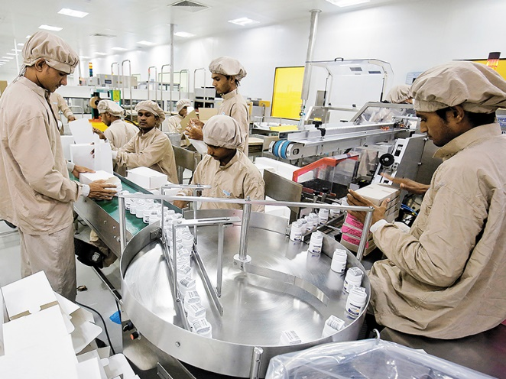
6. Action of solvents, reagents on reaction vessel: Some solvent and reagents may reacts with metals of the reaction vessels during the manufacturing process and may dissolved these metals which appears as impurities in the final product.

7. atmospheric contamination during the manufacturing process:
Atmosphere in the industrial is may contain dust particles and some gases such as SO₂ and H2S
8. Defective storage of final product: Some pharmaceutical chemicals undergo chemical decomposition if these are not properly stored.
9. Adulteration: Some pharmaceutical chemicals may be adulterated with cheaper substances.

