Principle and procedure involve in limit test for iron
Principle: limit test for iron depends upon the interaction of thioglycolic acid with iron in the presence of citric acid and ammonical alkaline medium, this results in the formation of purple or pink coloured ferrous salt of thioglycolic acid.

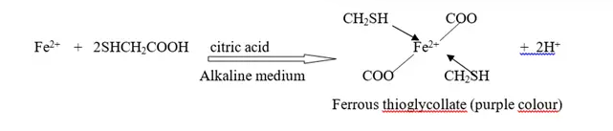
Procedure
Test solution
- Sample is dissolved in specific amount of water and then volume is made upto 40ml.
- Add 2ml of 20% w/v of citric acid
- Add 2 drops of thioglycolic acid
- Add ammonia to make the solution alkaline and adjust the volume to 50ml
- Keep a side for 5min

Standard solution
- 2ml of standard solution of iron diluted with water upto 40ml.
- Add 2ml of 20% w/v of citric acid
- Add 2 drops of thioglycolic acid
- Add ammonia to make the solution alkaline and adjust volume to 50ml
- Keep a side for 5min
Compare the test solution with standard, and test solution colour should not more than standard

